**Roblox Hack Download APK version 2.462.416719** 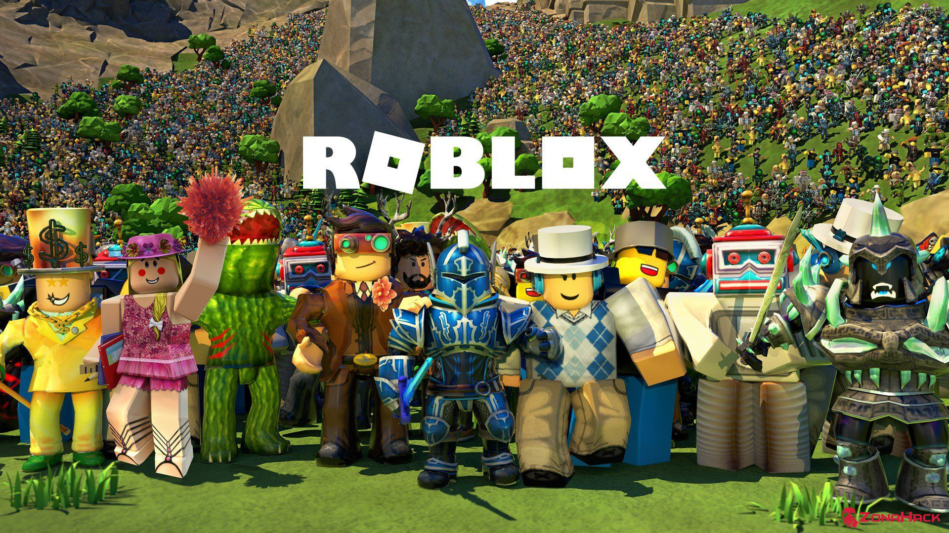

***Roblox MOD APK (Unlimited Robux/ Money)***, an online multiplayer game of bargaining involving both selling and buying, and creating virtual objects, allowing a lot of social interaction between players and the go dutch of vivid ideas between them, designed and released by Roblox Corporation in 2006.

If we talk about its prominence and reach, it has been downloaded over 100 million and has a rating of 4.4 on the Google Play store, rated by over 18 million users, which shows its popularity. So, let’s see its features and other information.

**Information about Roblox MOD APK**

|  |  |
| --- | --- |
| Application Name | ***Roblox MOD*** |
| Version | 2.462.416719 |
| Download Size | 93.24MB |
| Features | Unlimited Robux/ Money |
| Downloads | 100,000,000+ downloads |
| Updated on | January 14, 2021 |
| Offered by | Roblox Corporation |
| Released on | July 16, 2014 |
| Get It On | Google Play Store |

***Roblox MOD APK* App permissions:**

Version 2.462.416719 can access

1. In-app purchases- Google Play billing service
2. Photos/Media/Files- modify or delete the contents of your SD card, read the contents of your SD card
3. Wi-Fi connection information- view Wi-Fi connections
4. Other- Full network access, prevent the phone from sleeping, run at startup, view network connections.

**Features of Roblox Mod APK:**

**1.    Collection of lots of games:**

As we can see, this game has a huge no. of users base who creates their own game, so it has an unlimited no. of games available to be played. So, it’s up to you if you wish to make your world or want to enjoy in other people’s world, which is way more captivating on its own. 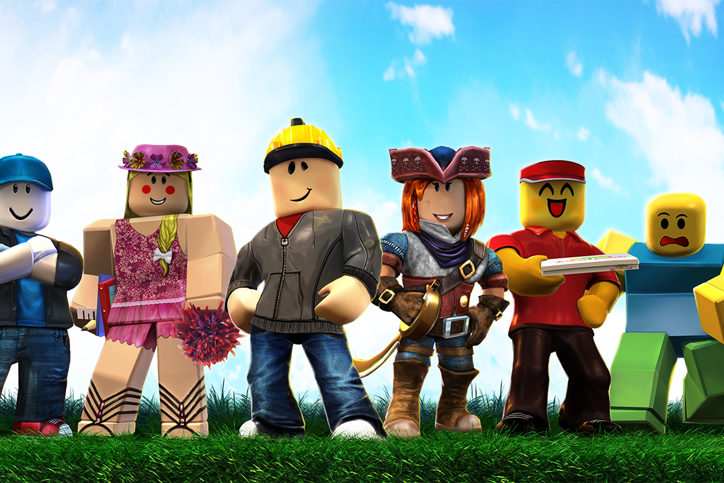

**2.    Expression of creativeness:**

It provides you the platform to express what’s in your mind, what do you want to create, which makes it unique from other games. You are free to customize your avatar’s costume, face, equipment, and many more.

**3.    Graphics:**

It has impressive and eye-catching animation and graphics that provide exposure to those also who never played any mobile game before. It contains various distinct inbuilt characters, avatars with real-world-like costumes, and gadgets that make it more thrilling for players. For enjoying this game, you need to use your brain only and move your fingers on the screen.

**4.    Unlimited money:**

It provides an unlimited amount of money (Robux) using which you can buy any gadgets, dresses, accessories, and other things and use them to make your game more enticing and thrilling for others too.

**5.    Unlimited level of games:**

It provides you with innumerable levels with different avatars and features, which makes it more enjoyable to play with your pals and colleagues. You can enjoy different levels created by other gamers or can create your own.

**6.    Chatting or texting is available:**

 You can chat with the other combatants or your friends while playing without any issues.

**7.    Hack features:**

It provides you with an unlimited amount of Robux/money which will help you in buying everything you’ll need and will help you to get all three memberships in the Builders Club.

**8.    Buying and Selling:**

It permits the participants to create virtual objects using inbuilt accessories, buy and sell other objects. Anyone can buy costumes but can be sold only by the players who have a membership of Builders Club.

Only administrators are allowed to sell distinct objects like packages, body parts, equipment, and accessories under the official user account.

Items which are having limited status can only be exchanged with the three builders club or can be sold in the catalog.

Robux, the virtual currency used for buying objects can be obtained through selling objects, through real-life purchasing, or by winning it daily by a membership.

It’s free to play but you can spend real money to get Robux, the currency used in Roblox to be spent on buying accessories and equipment and to develop your game more and more.

You can get a membership of the privilege club “Builders Club” which will provide you more privileges and a Robux stipend daily.

How to Download Roblox mod apk for android: